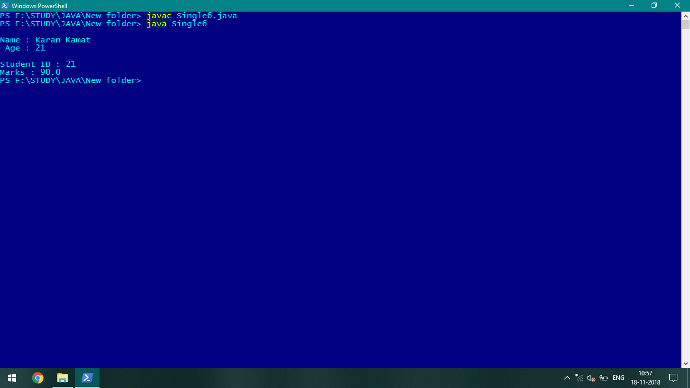

Fig: Output of Single inheritance java program.

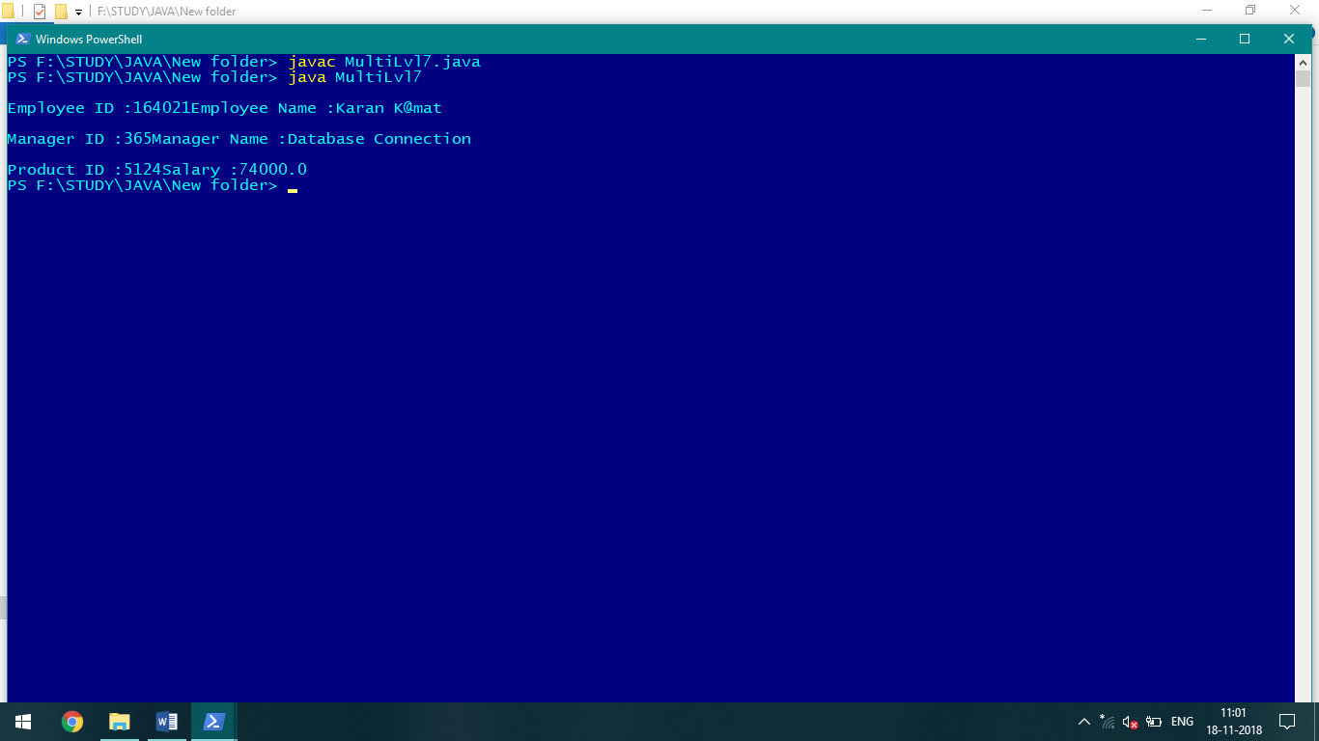

Fig: Output of Multilevel inheritance java program

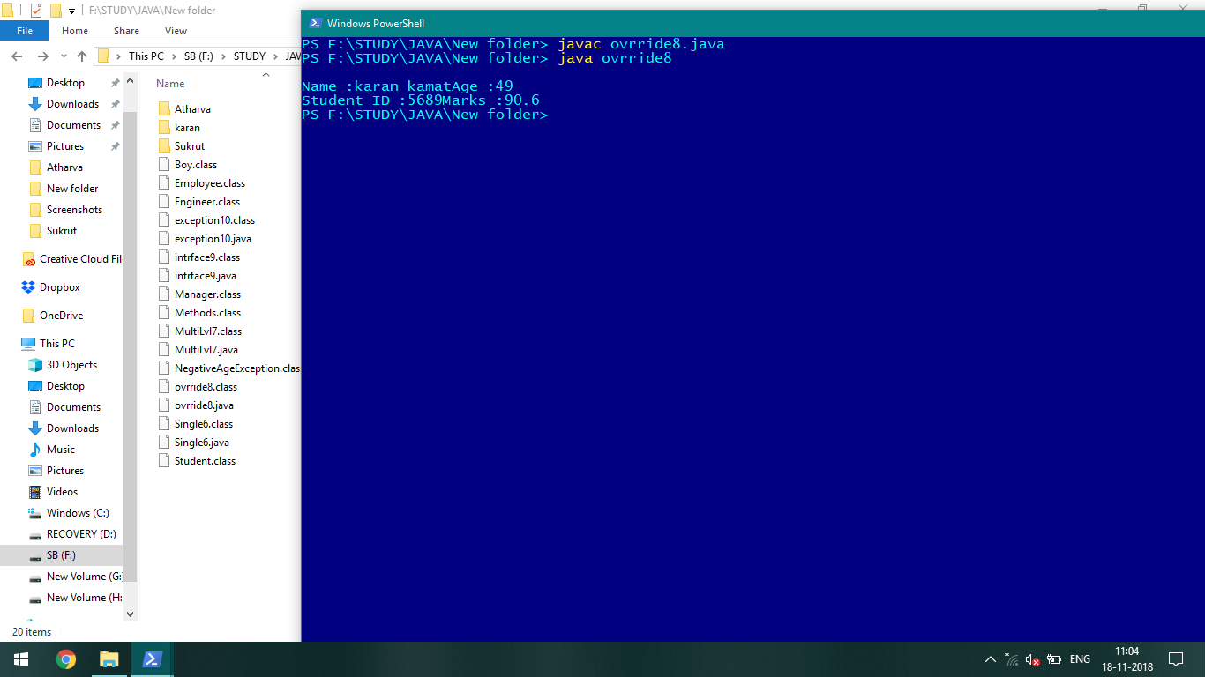

Fig: Output of function overriding method java.

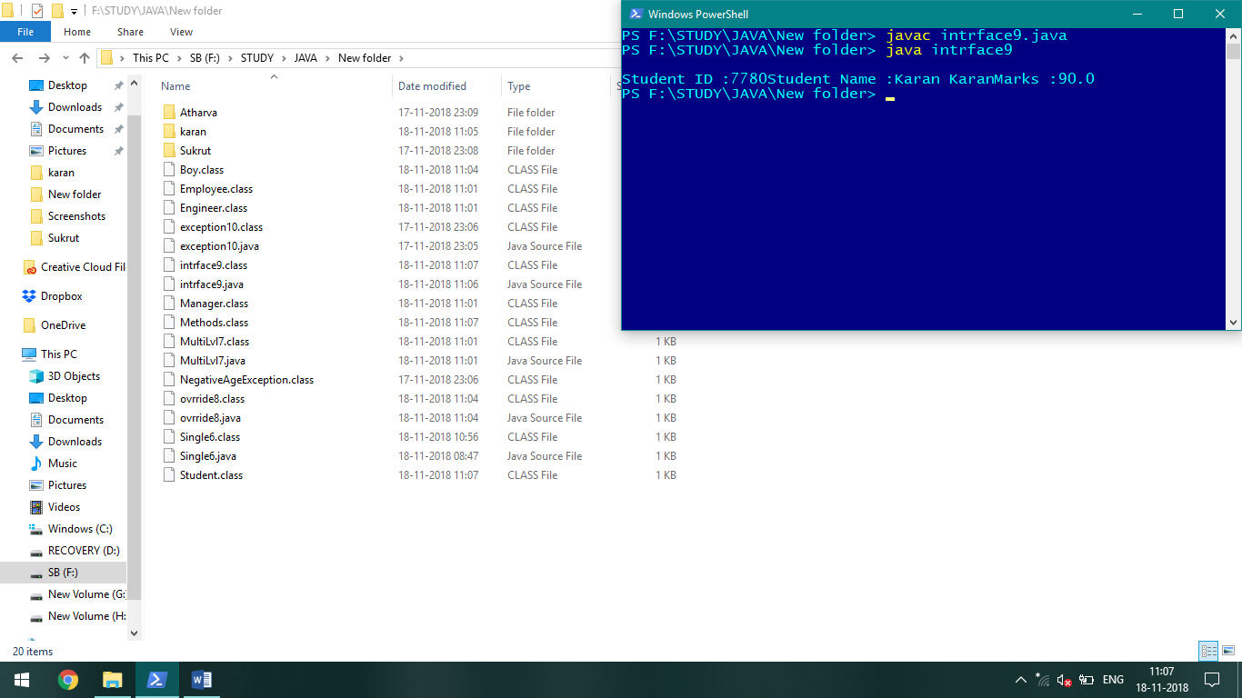

Fig: Output of interface java program

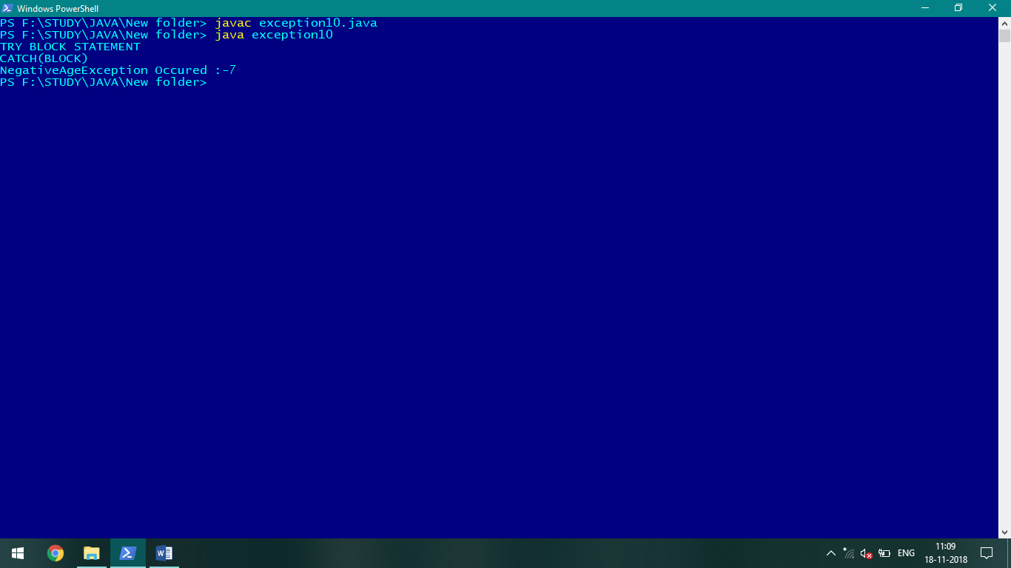

Fig: Output of exception handling java program.